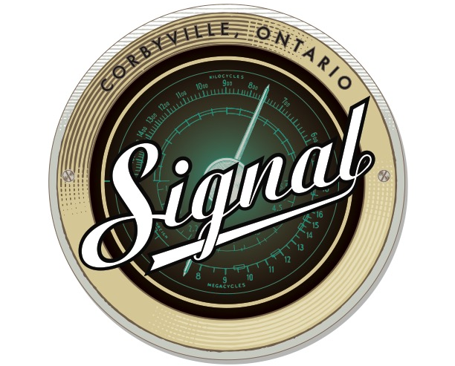
SIGNAL MARKET
VENDOR APPLICATION

Thank you for your interest in becoming a participant at Signal’s market. We are welcoming vendors (homemade/homegrown products only), buskers and businesses.

Participants are required to bring everything they need (tables, chairs, etc.). Tents/booths/stands can be set up in a 10x10 space on the front grass at Signal (first come first serve basis). This is a casual market so it is up to the vendors to do all set-up/tear down duties.

The cost for vendors is $25. Vendors can come as frequently as they’d like. The market will run from 11 a.m. to 5 p.m. every Saturday and Sunday starting June 30 to Thanksgiving weekend. We require payment at least three days before the first market day you intend to come in the form of cash or cheque made out to Signal Brewing Company. The market is rain or shine. No refunds once payment has been made.

Please fill out the form below and send it to Ashley Clark at ashley@signal.beer.

FULL NAME: _________________________________

BUSINESS NAME: _________________________________

BUSINESS WEBSITE: _________________________________

PRODUCTS/SERVICES TO BE SOLD: _________________________________

EMAIL: _________________________________

PHONE: _________________________________

FIRST MARKET DATE (in attendance): _____________________________

* Please note the market is rain or shine so there will be no refunds or cancellations once payment has been made. *

